Small Rhombicosidodecahedron

Definition
# Source: AI Source: Provided by: [Data Path: Persons Table -> ID Column: 1, Name_En Column: Motasem Essam] -> From: [ChatGPT] on [7/25/2026]
The Small Rhombicosidodecahedron, also known as the Rhombicosidodecahedron, is a convex Archimedean solid composed of 62 regular polygonal faces: 20 equilateral triangles, 30 regular squares, and 12 regular pentagons.
It has 60 vertices and 120 edges. At every vertex, one triangle, two squares, and one pentagon meet in the same arrangement.
Its vertex configuration is 3.4.5.4.

Geometric Structure
# Source: AI Source: Provided by: [Data Path: Persons Table -> ID Column: 1, Name_En Column: Motasem Essam] -> From: [ChatGPT] on [7/25/2026]
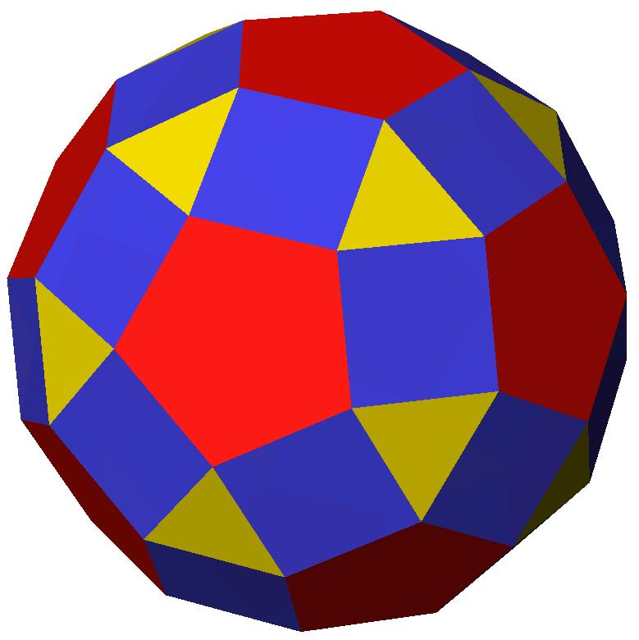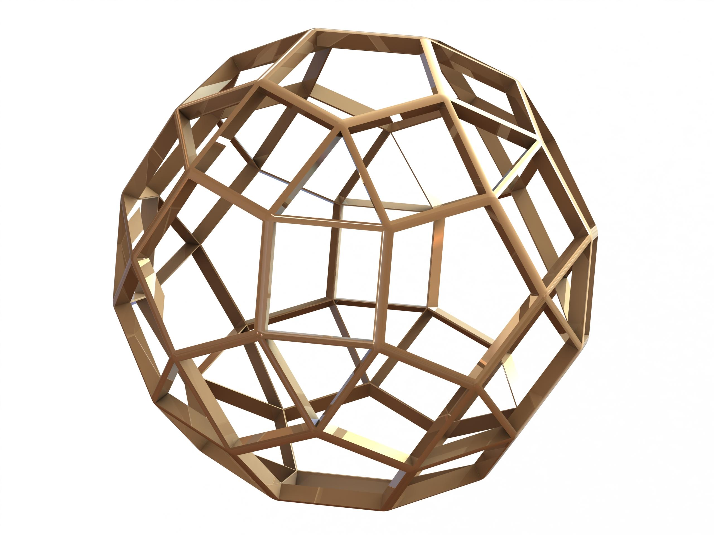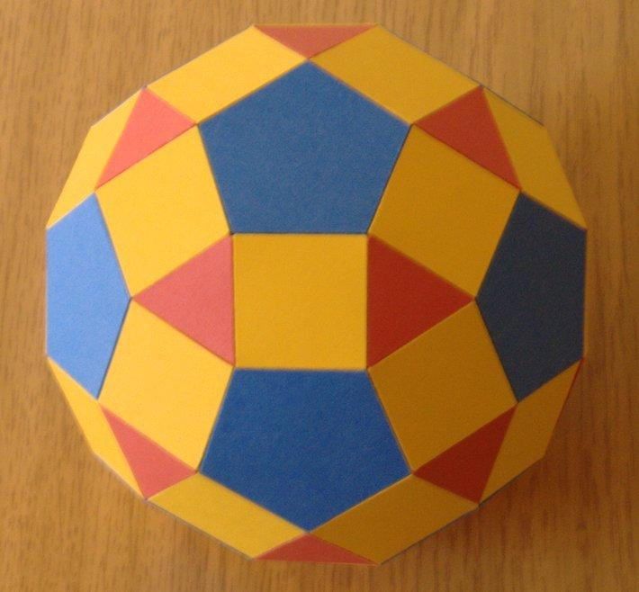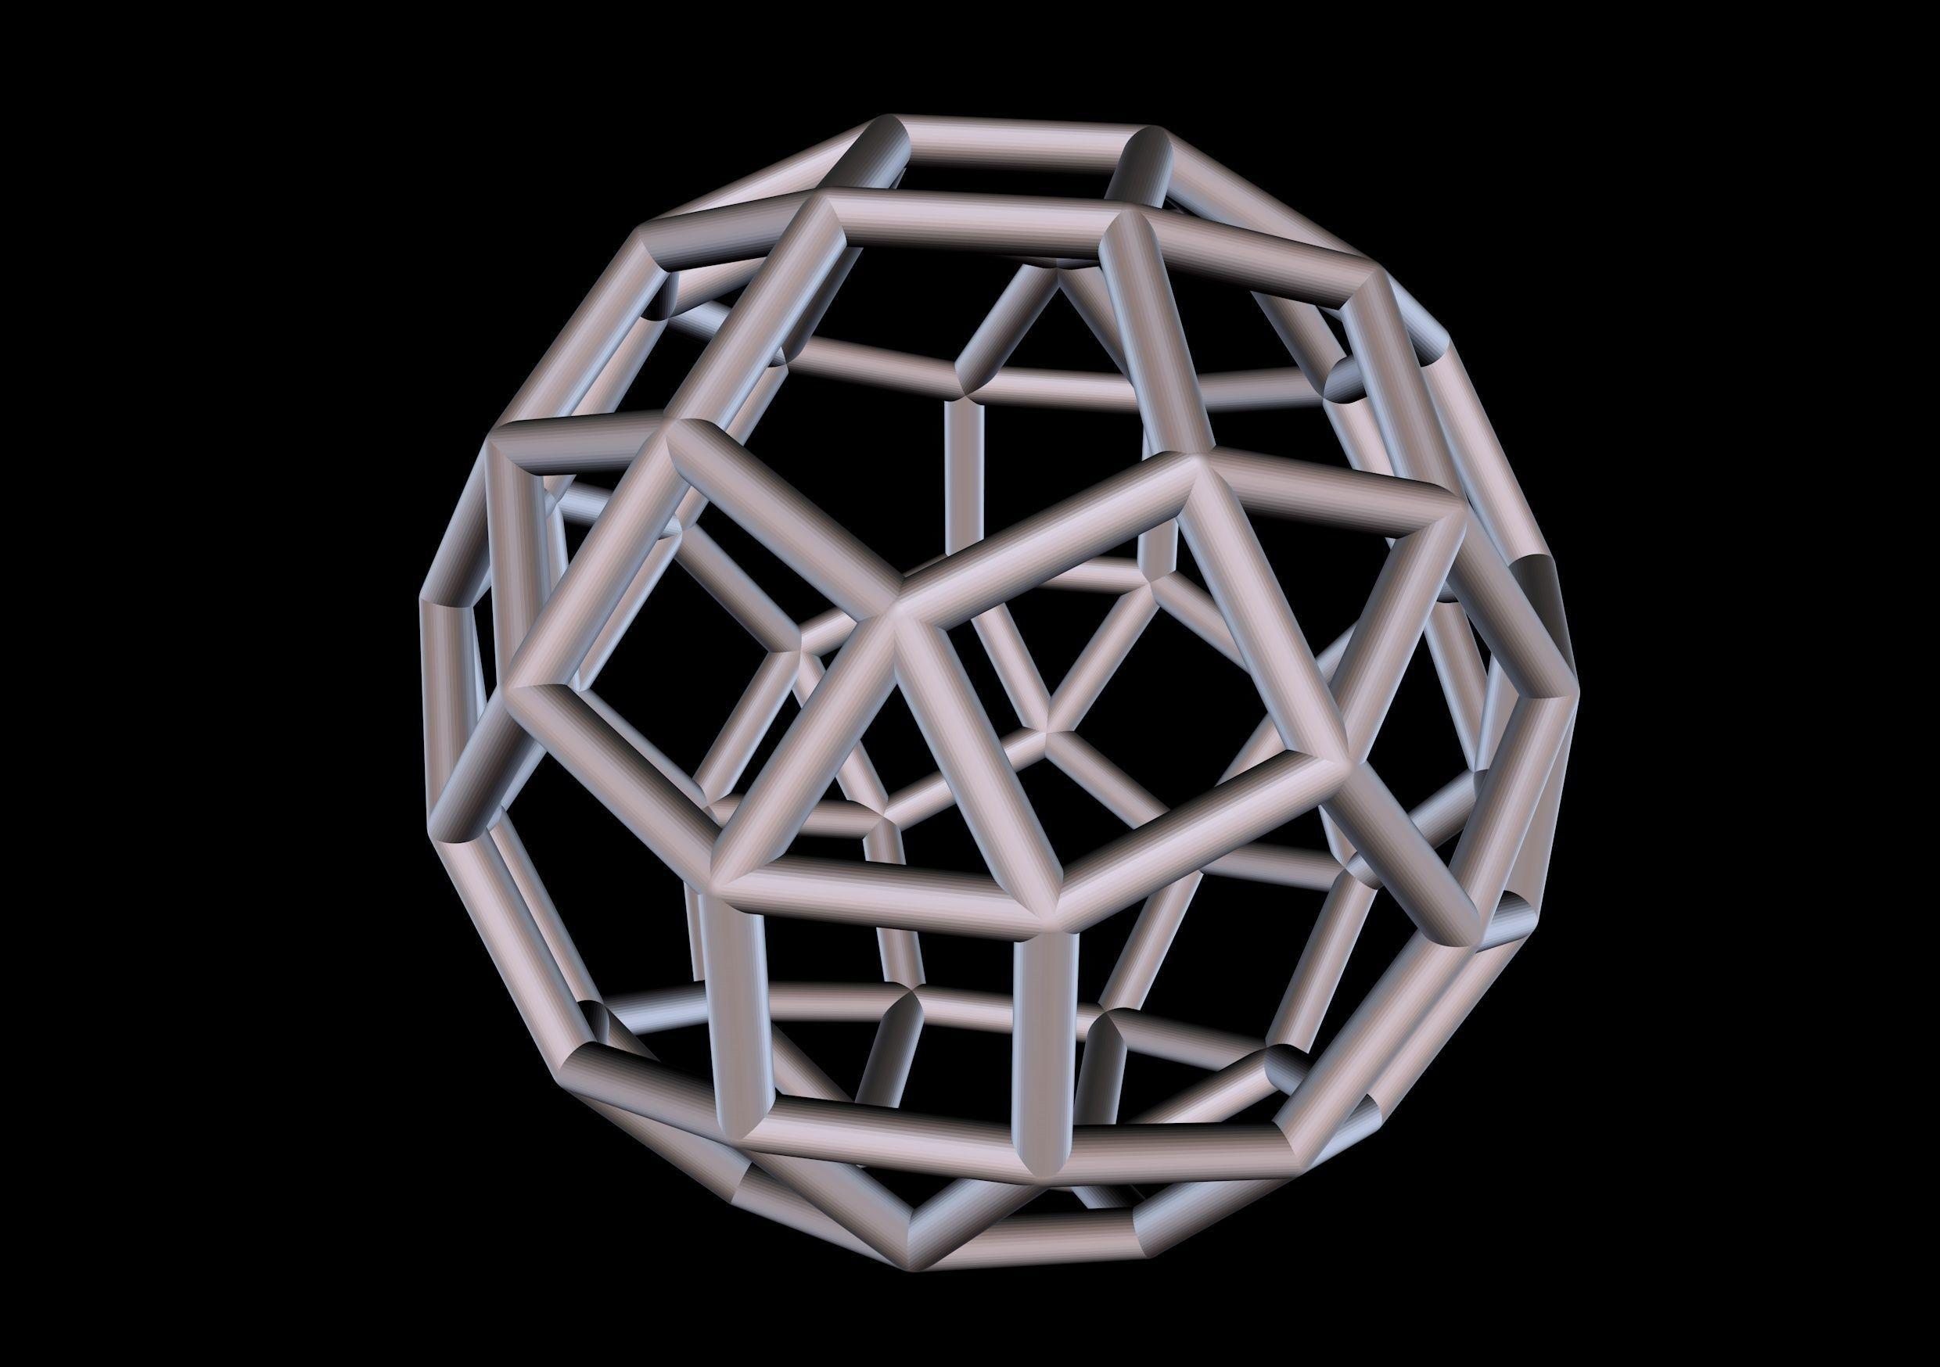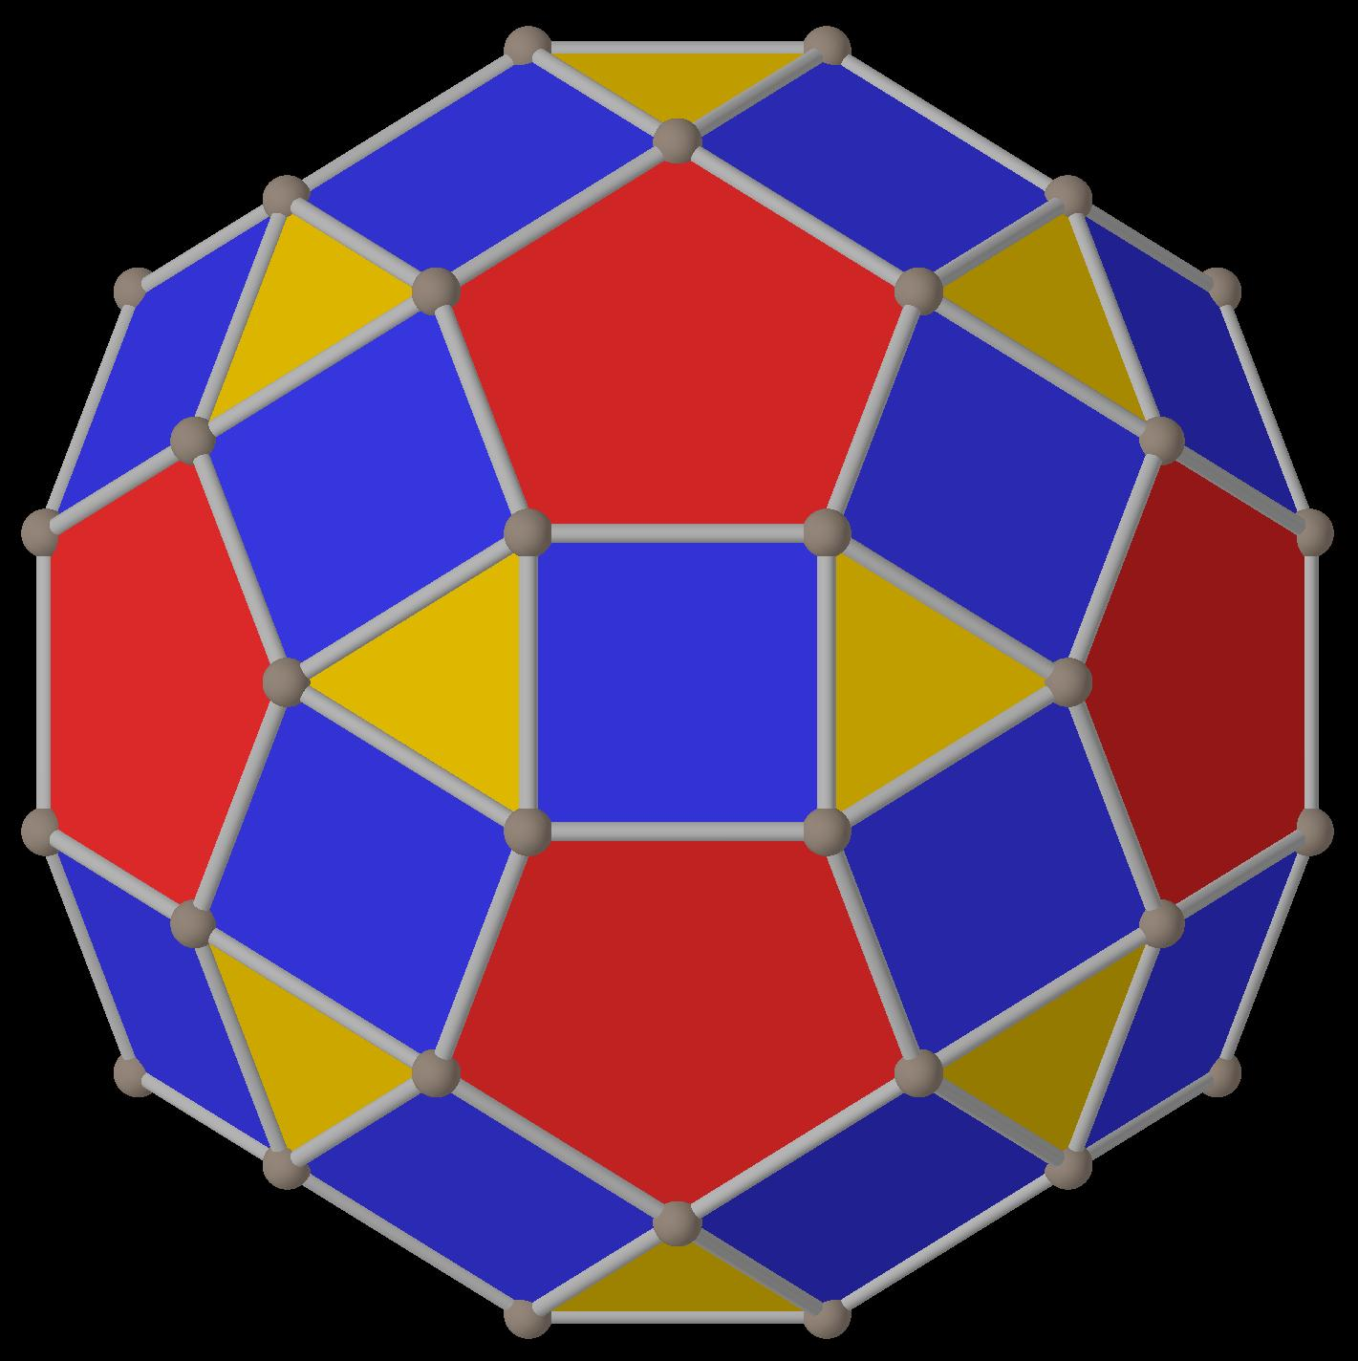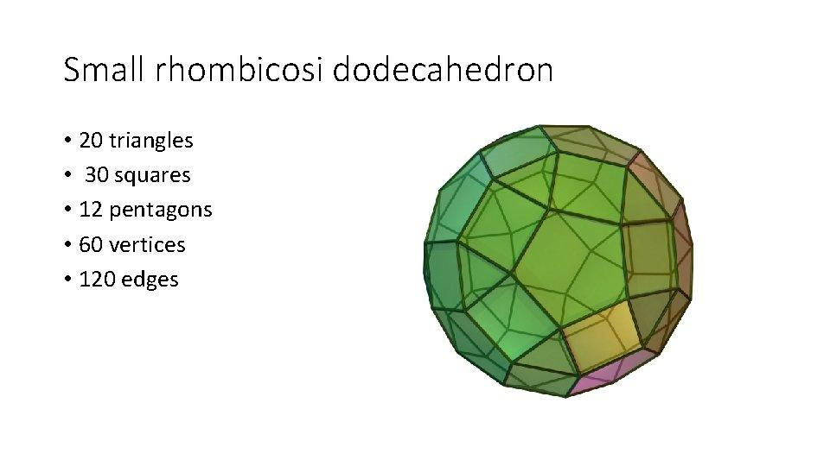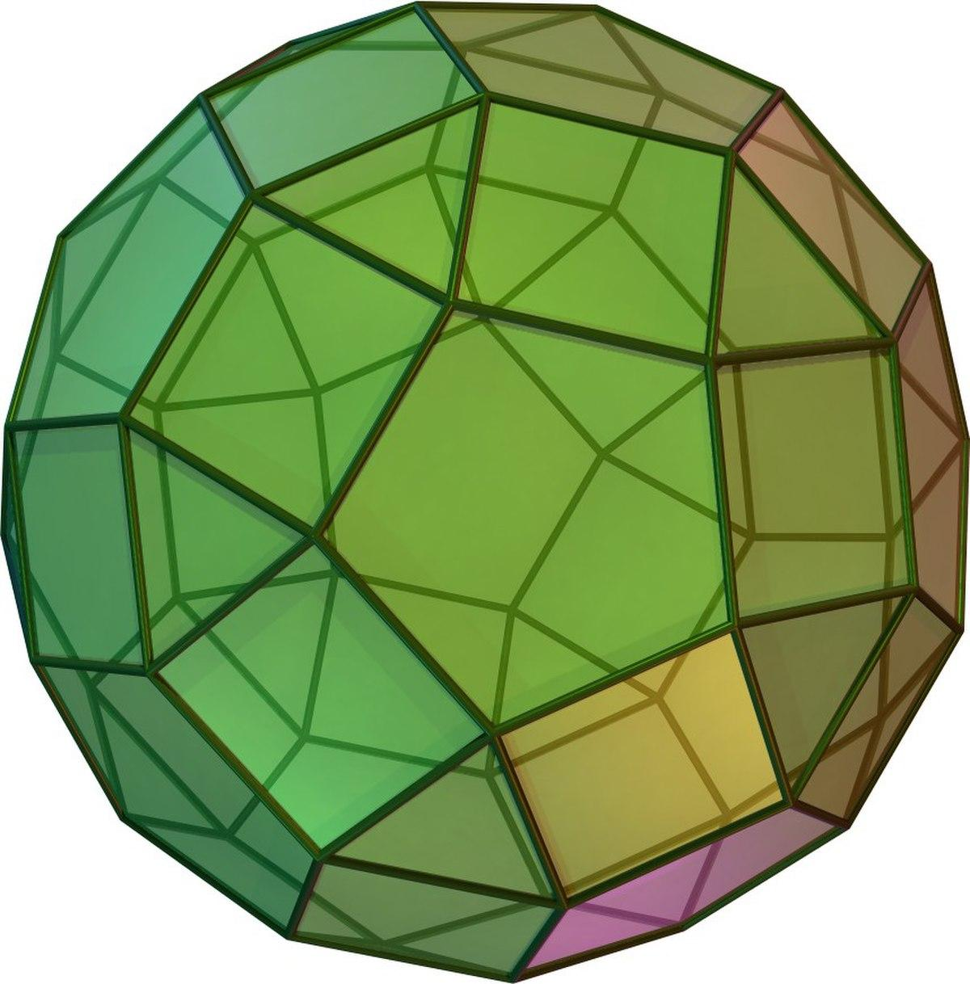
The solid consists of three types of regular polygonal faces:
- 20 Triangular Faces: Equilateral triangles.
- 30 Square Faces: Regular squares.
- 12 Pentagonal Faces: Regular pentagons.
Its polygonal faces are arranged uniformly around every vertex.

Face Composition
# Source: AI Source: Provided by: [Data Path: Persons Table -> ID Column: 1, Name_En Column: Motasem Essam] -> From: [ChatGPT] on [7/25/2026]
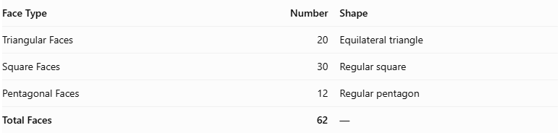
Face Type | Number | Shape
Triangular Faces | 20 | Equilateral triangle
Square Faces | 30 | Regular square
Pentagonal Faces | 12 | Regular pentagon
Total Faces | 62 | —

Mathematical Properties
# Source: AI Source: Provided by: [Data Path: Persons Table -> ID Column: 1, Name_En Column: Motasem Essam] -> From: [ChatGPT] on [7/25/2026]
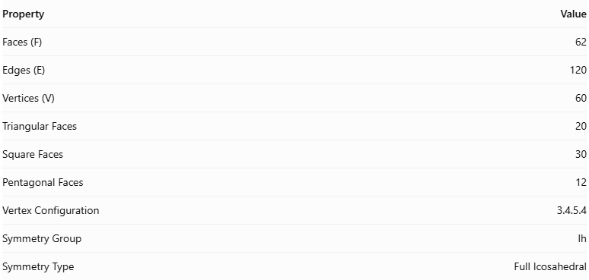
Property | Value
Faces (F) | 62
Edges (E) | 120
Vertices (V) | 60
Triangular Faces | 20
Square Faces | 30
Pentagonal Faces | 12
Vertex Configuration | 3.4.5.4
Symmetry Group | Ih
Symmetry Type | Full Icosahedral

Euler's Formula
# Source: AI Source: Provided by: [Data Path: Persons Table -> ID Column: 1, Name_En Column: Motasem Essam] -> From: [ChatGPT] on [7/25/2026]
For a convex polyhedron:
$$V-E+F=2$$
Substituting the values:
$$60-120+62=2$$
Therefore, Euler's formula is satisfied.

Surface Area
# Source: AI Source: Provided by: [Data Path: Persons Table -> ID Column: 1, Name_En Column: Motasem Essam] -> From: [ChatGPT] on [7/25/2026]
For edge length $a$, the surface area is:
$$A=a^{2}[30+5\sqrt{3}+3\sqrt{25+10\sqrt{5}}]$$
Approximately:
$$A≈59.30598a^{2}$$

Volume
# Source: AI Source: Provided by: [Data Path: Persons Table -> ID Column: 1, Name_En Column: Motasem Essam] -> From: [ChatGPT] on [7/25/2026]
For edge length $a$, the volume is:
$$V=\frac{a^{3}}{3}(60+29\sqrt{5})$$
Approximately:
$$V≈41.61532a^{3}$$
The vertex configuration means that one triangle, one square, one pentagon, and another square meet at every vertex.

Geometric Characteristics
# Source: AI Source: Provided by: [Data Path: Persons Table -> ID Column: 1, Name_En Column: Motasem Essam] -> From: [ChatGPT] on [7/25/2026]
- It is a convex Archimedean solid.
- All faces are regular polygons.
- All edges have equal length.
- Every vertex has the same arrangement of faces.
- It has full icosahedral symmetry.
- It contains three different polygon types: triangles, squares, and pentagons.
- Its dual polyhedron is the Deltoidal Hexecontahedron.
- It is different from the Great Rhombicosidodecahedron.

Geometric Construction
# Source: AI Source: Provided by: [Data Path: Persons Table -> ID Column: 1, Name_En Column: Motasem Essam] -> From: [ChatGPT] on [7/25/2026]
The Small Rhombicosidodecahedron is related geometrically to the icosahedron and dodecahedron.
Its construction can be understood through the arrangement of triangular, square, and pentagonal faces.
The construction involves:
- Begin with the geometric arrangement of an icosahedron and a dodecahedron in dual positions.
- Expand the two solids while preserving their face orientations.
- Arrange the expanded solids so that square regions appear between corresponding faces.
- Fill the gaps with 30 square faces.
- Preserve the 20 triangular faces and 12 pentagonal faces.
- Adjust the arrangement so that all resulting edges have equal lengths.
- Verify that every vertex has the configuration 3.4.5.4.
The resulting solid contains 20 triangles, 30 squares, and 12 pentagons.

Related Geometric Solids

Icosahedron
# Source: AI Source: Provided by: [Data Path: Persons Table -> ID Column: 1, Name_En Column: Motasem Essam] -> From: [ChatGPT] on [7/25/2026]
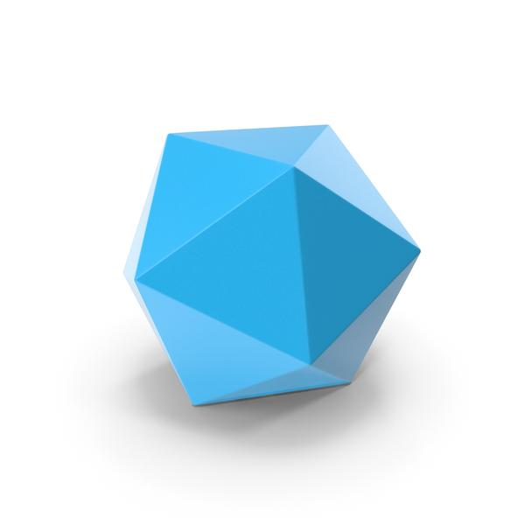
A regular polyhedron composed of 20 equilateral triangular faces.

Dodecahedron
# Source: AI Source: Provided by: [Data Path: Persons Table -> ID Column: 1, Name_En Column: Motasem Essam] -> From: [ChatGPT] on [7/25/2026]
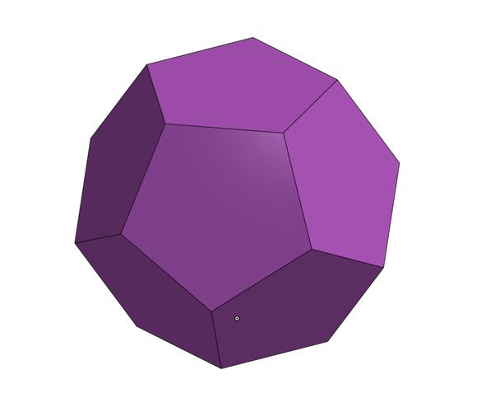
A regular polyhedron composed of 12 regular pentagonal faces.

Great Rhombicosidodecahedron
# Source: AI Source: Provided by: [Data Path: Persons Table -> ID Column: 1, Name_En Column: Motasem Essam] -> From: [ChatGPT] on [7/25/2026]
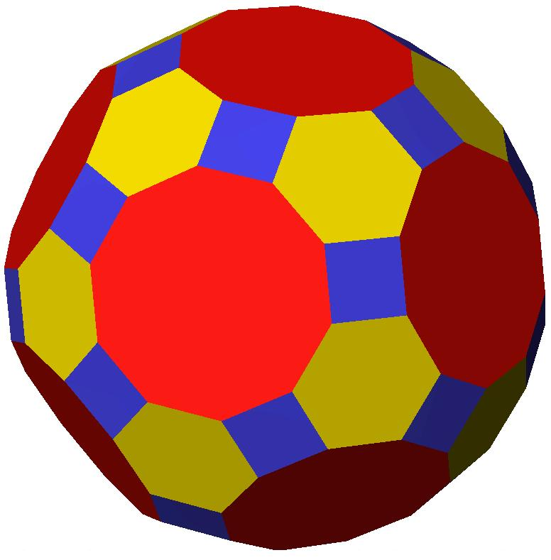
A different Archimedean solid composed of 30 squares, 20 hexagons, and 12 decagons.

Deltoidal Hexecontahedron
# Source: AI Source: Provided by: [Data Path: Persons Table -> ID Column: 1, Name_En Column: Motasem Essam] -> From: [ChatGPT] on [7/25/2026]
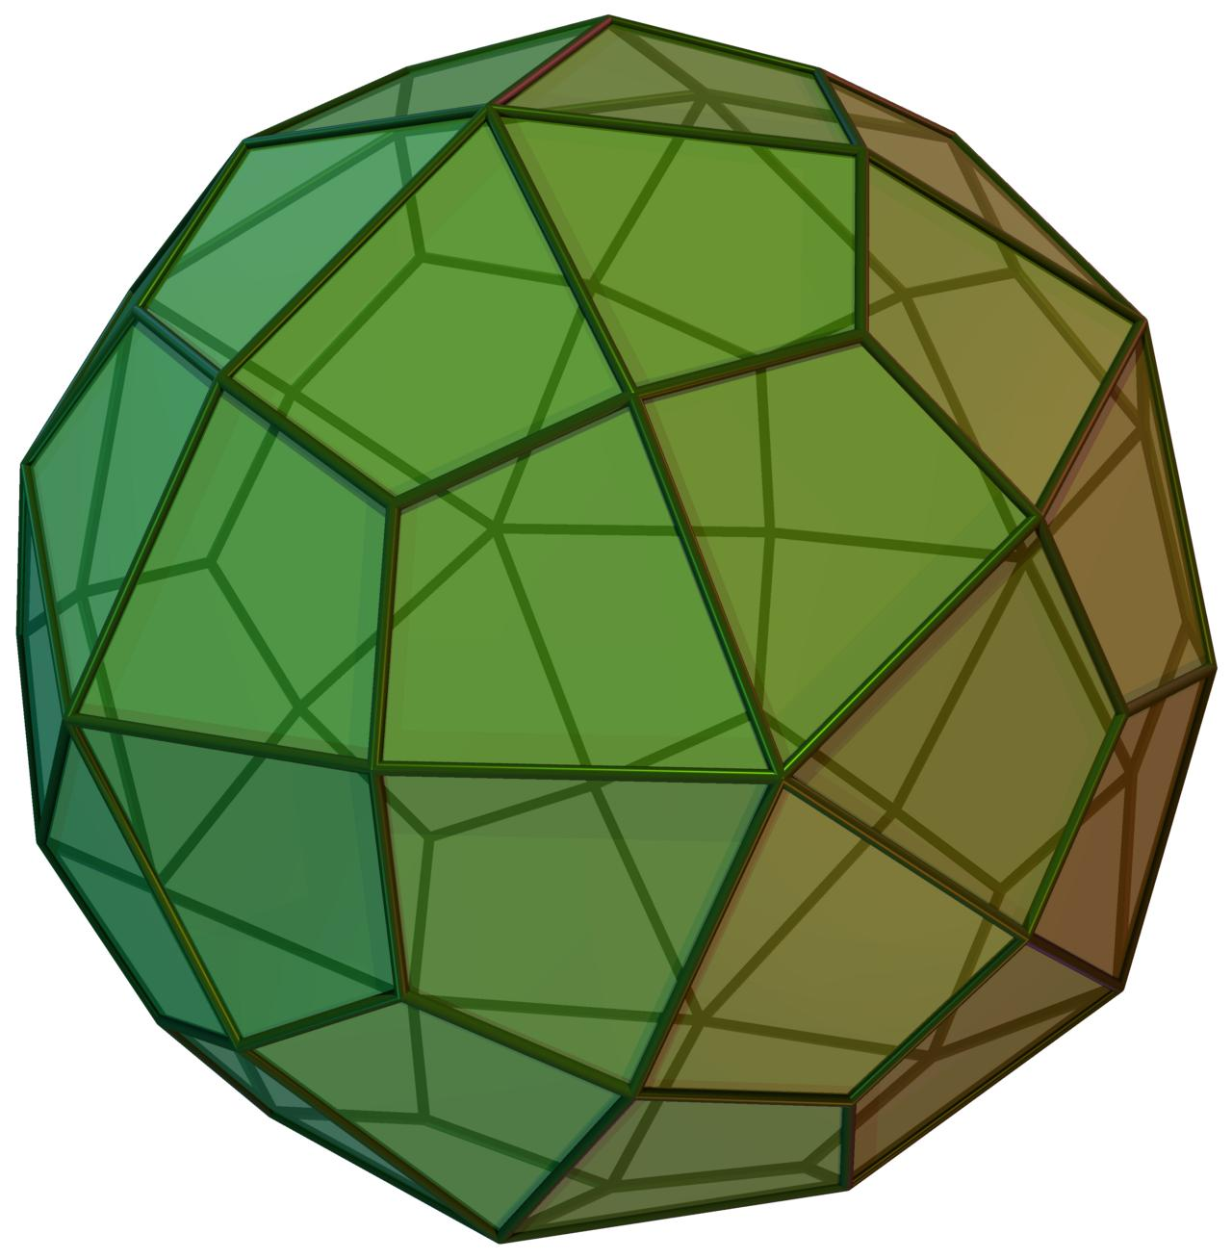
The dual polyhedron of the Small Rhombicosidodecahedron.

Construction of Small Rhombicosidodecahedron

Geometric Instruments Used
# Source: AI Source: Provided by: [Data Path: Persons Table -> ID Column: 1, Name_En Column: Motasem Essam] -> From: [ChatGPT] on [7/25/2026]
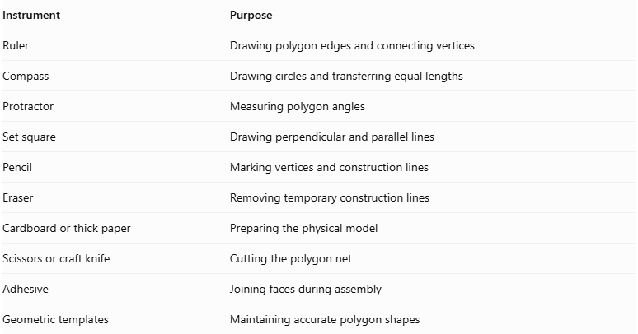
Instrument | Purpose
Ruler | Drawing polygon edges and connecting vertices
Compass | Drawing circles and transferring equal lengths
Protractor | Measuring polygon angles
Set square | Drawing perpendicular and parallel lines
Pencil | Marking vertices and construction lines
Eraser | Removing temporary construction lines
Cardboard or thick paper | Preparing the physical model
Scissors or craft knife | Cutting the polygon net
Adhesive | Joining faces during assembly
Geometric templates | Maintaining accurate polygon shapes

Instrument-Based Construction Procedures

Establishing the Common Edge Length
# Source: AI Source: Provided by: [Data Path: Persons Table -> ID Column: 1, Name_En Column: Motasem Essam] -> From: [ChatGPT] on [7/25/2026]
- Choose a convenient edge length $a$.
- Draw a reference line segment using a ruler.
- Use a compass to transfer the same length to the remaining polygon constructions.
- Keep this edge length consistent for every triangle, square, and pentagon.
All 120 edges of the uniform solid have equal length.

Constructing the Equilateral Triangular Faces
# Source: AI Source: Provided by: [Data Path: Persons Table -> ID Column: 1, Name_En Column: Motasem Essam] -> From: [ChatGPT] on [7/25/2026]
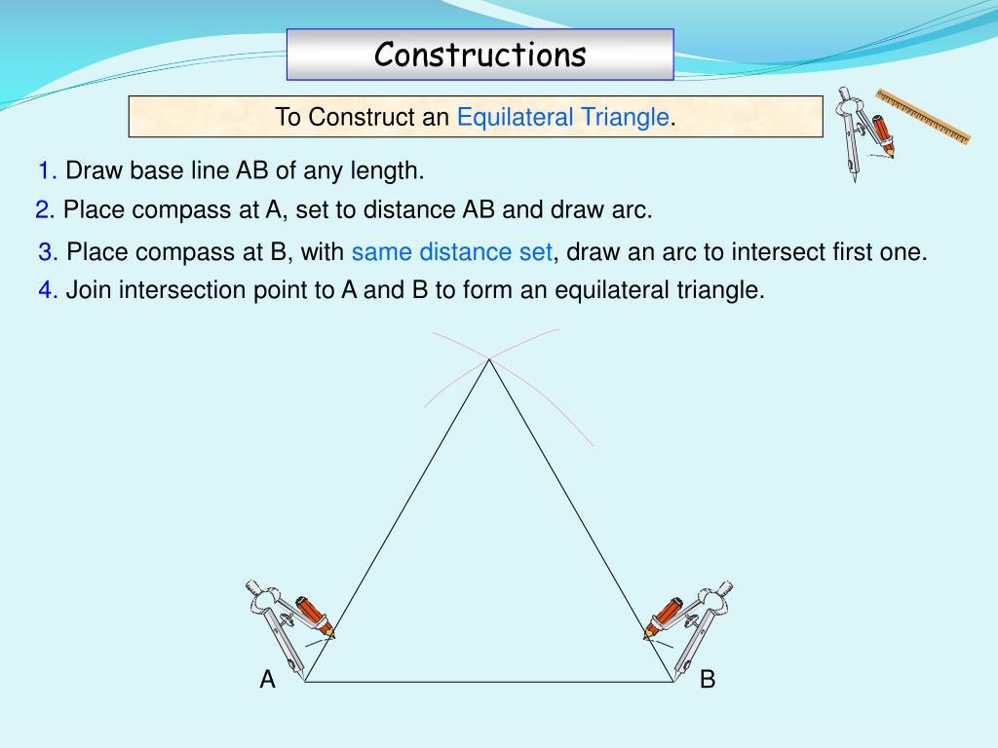
- Draw a reference line segment.
- Set the compass opening to the required edge length.
- Draw an arc from each endpoint.
- Mark the intersection of the two arcs.
- Connect the three vertices using a ruler.
- Verify that all three sides are equal and all interior angles are 60°.
Repeat this construction to prepare 20 equilateral triangular faces.

Constructing the Square Faces
# Source: AI Source: Provided by: [Data Path: Persons Table -> ID Column: 1, Name_En Column: Motasem Essam] -> From: [ChatGPT] on [7/25/2026]
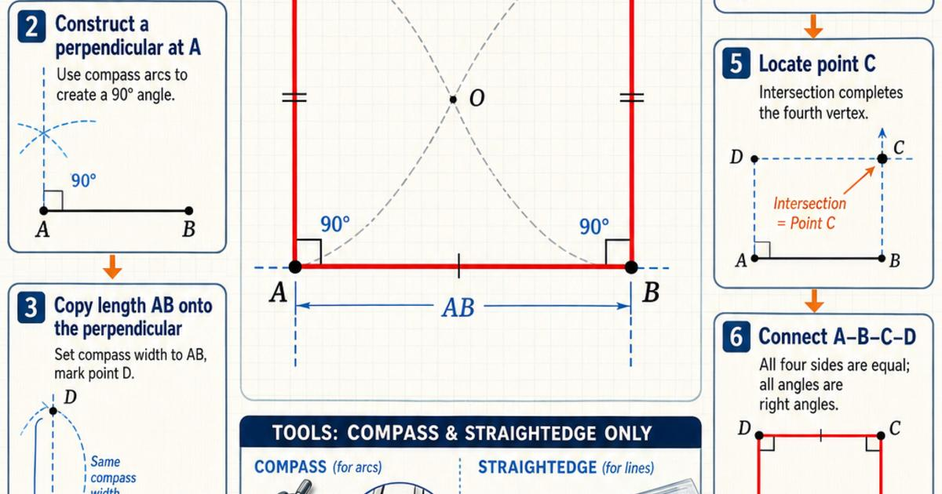
- Draw a reference line segment.
- Construct a perpendicular line at one endpoint.
- Mark a second side of equal length.
- Construct the remaining perpendicular sides.
- Complete the square.
- Verify that all four sides are equal and all interior angles are 90°.
Repeat this construction to prepare 30 square faces.

Constructing the Regular Pentagonal Faces
# Source: AI Source: Provided by: [Data Path: Persons Table -> ID Column: 1, Name_En Column: Motasem Essam] -> From: [ChatGPT] on [7/25/2026]
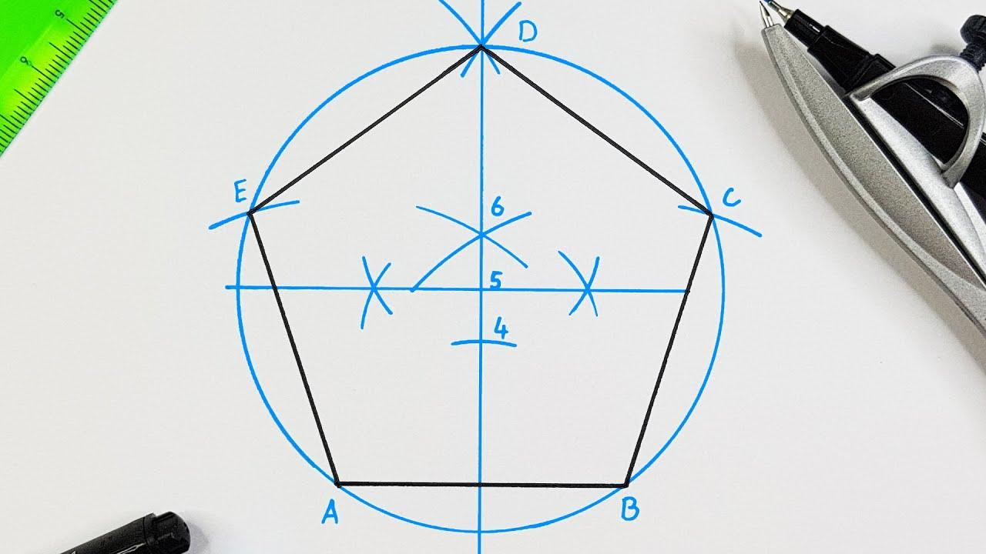
- Draw a circle using a compass.
- Mark its center.
- Divide the circumference into five equal angular sections.
- Each central angle measures 72°.
- Mark the five vertices.
- Connect consecutive vertices using a ruler.
- Verify that all five sides are equal and all interior angles are 108°.
Repeat this construction to prepare 12 regular pentagonal faces.
The central angle between consecutive vertices is:
$$\frac{{360}^{°}}{5}={72}^{°}$$

Establishing the Vertex Arrangement
# Source: AI Source: Provided by: [Data Path: Persons Table -> ID Column: 1, Name_En Column: Motasem Essam] -> From: [ChatGPT] on [7/25/2026]
The Small Rhombicosidodecahedron uses the same arrangement of faces around every vertex.
- Select one triangular face as the reference face.
- Identify one of its vertices.
- Position a square face along one adjacent edge.
- Position a pentagonal face along the next required adjacent edge.
- Position a second square face so that all four faces meet at the same vertex.
- Check their interior angles:
$${60}^{°}+{90}^{°}+{108}^{°}+{90}^{°}={348}^{°}$$
- Repeat the arrangement throughout the model while preserving equal edge lengths and the correct face adjacency.

Constructing the Complete Polyhedron
# Source: AI Source: Provided by: [Data Path: Persons Table -> ID Column: 1, Name_En Column: Motasem Essam] -> From: [ChatGPT] on [7/25/2026]
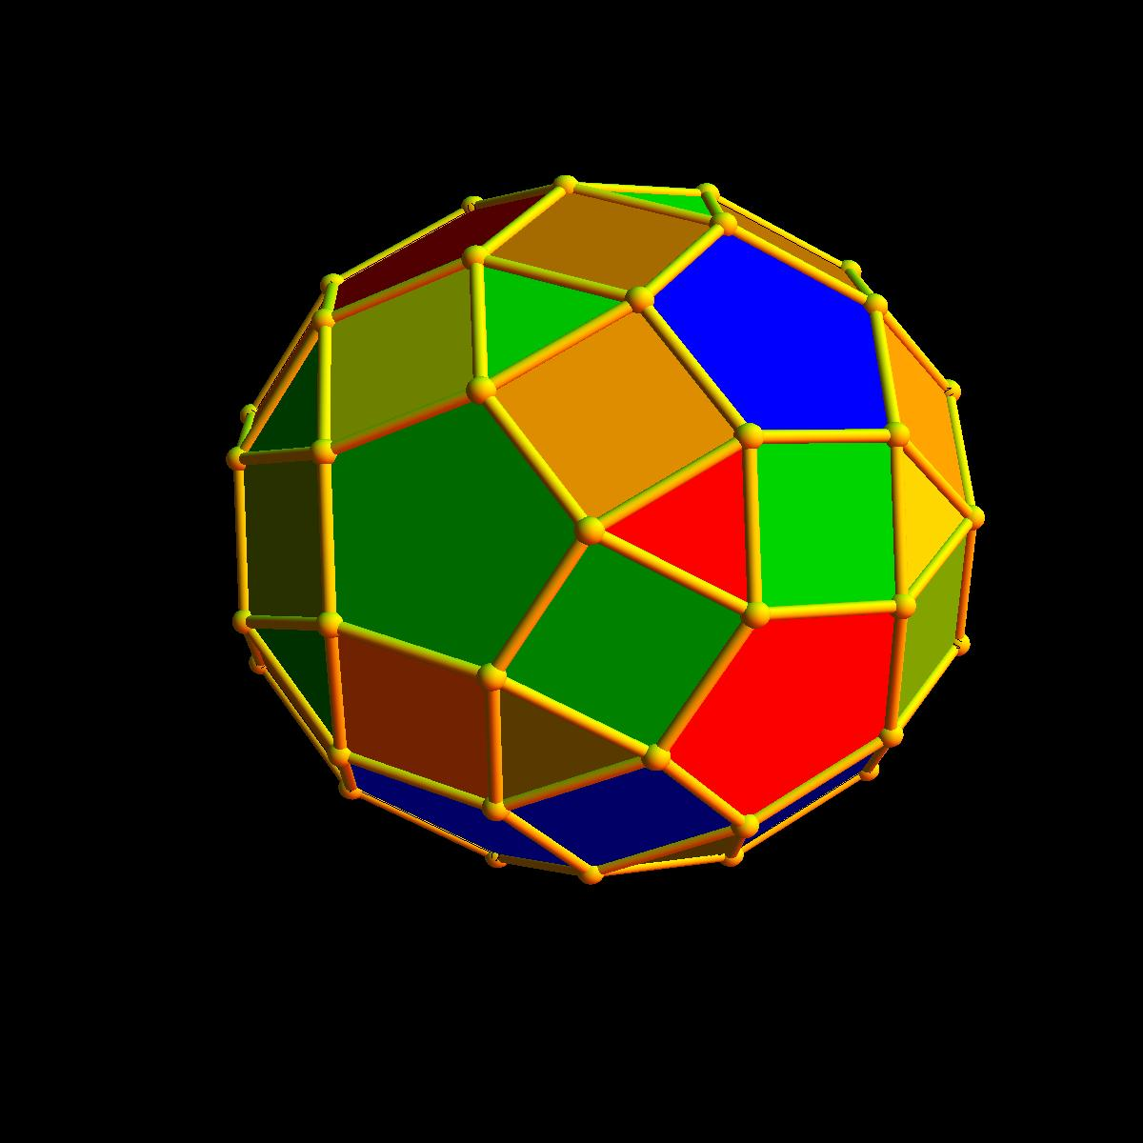
- Use a reference net of the Small Rhombicosidodecahedron.
- Transfer the net onto cardboard or thick paper.
- Preserve the exact number and arrangement of all polygonal faces.
- Cut around the outer boundary of the net.
- Fold along the shared edges.
- Join the matching edges carefully.
- Check that all faces close into one solid without gaps or unintended overlaps.
- Verify the final face inventory:
- 20 triangles.
- 30 squares.
- 12 pentagons.

Key Points
# Source: AI Source: Provided by: [Data Path: Persons Table -> ID Column: 1, Name_En Column: Motasem Essam] -> From: [ChatGPT] on [7/25/2026]
- The Small Rhombicosidodecahedron is one of the 13 classical Archimedean solids.
- It has 62 faces, 120 edges, and 60 vertices.
- Its faces consist of 20 triangles, 30 squares, and 12 pentagons.
- Its vertex configuration is 3.4.5.4.
- It has full icosahedral symmetry.
- Its dual is the Deltoidal Hexecontahedron.
- It should not be confused with the Great Rhombicosidodecahedron.

Main Classification
# Source: AI Source: Provided by: [Data Path: Persons Table -> ID Column: 1, Name_En Column: Motasem Essam] -> From: [ChatGPT] on [7/25/2026]
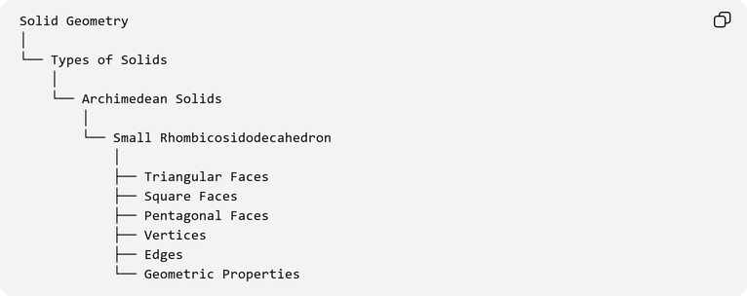
Solid Geometry
│
└── Types of Solids
│
└── Archimedean Solids
│
└── Small Rhombicosidodecahedron
│
├── Triangular Faces
├── Square Faces
├── Pentagonal Faces
├── Vertices
├── Edges
└── Geometric Properties

Conclusion
# Source: AI Source: Provided by: [Data Path: Persons Table -> ID Column: 1, Name_En Column: Motasem Essam] -> From: [ChatGPT] on [7/25/2026]
The Small Rhombicosidodecahedron is a convex Archimedean solid characterized by its combination of equilateral triangles, squares, and regular pentagons. Its uniform vertex arrangement, icosahedral symmetry, and relationship to the icosahedron and dodecahedron make it an important example of a complex uniform polyhedron.
With 62 faces, 120 edges, and 60 vertices, it demonstrates how different regular polygons can be combined to create a highly symmetrical three-dimensional geometric structure.

